Terraform installation in Aws
https://developer.hashicorp.com/terraform/install ---------- go to this url here we have all OS terraform installation urls
Create instance then run this command ate time,
wget -O - https://apt.releases.hashicorp.com/gpg | sudo gpg --dearmor -o /usr/share/keyrings/hashicorp-archive-keyring.gpg
echo "deb [arch=$(dpkg --print-architecture) signed-by=/usr/share/keyrings/hashicorp-archive-keyring.gpg] https://apt.releases.hashicorp.com $(lsb_release -cs) main" | sudo tee /etc/apt/sources.list.d/hashicorp.list
sudo apt update && sudo apt install terraform

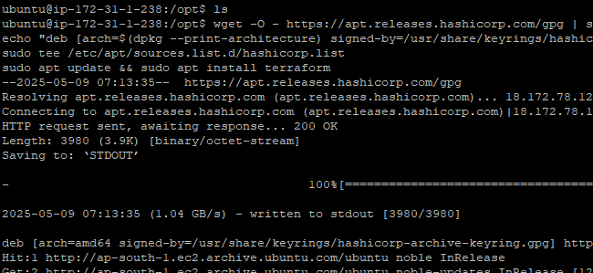
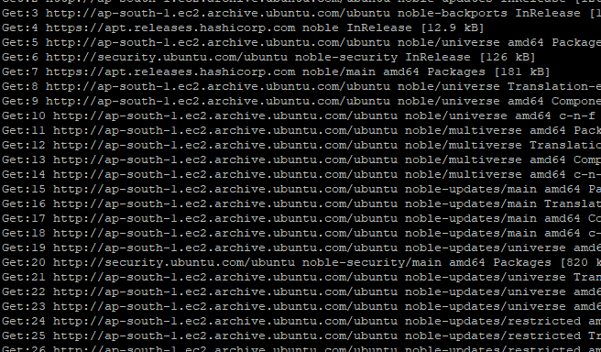

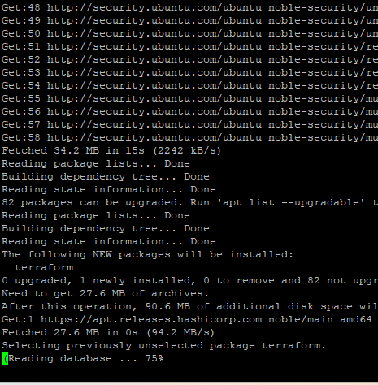

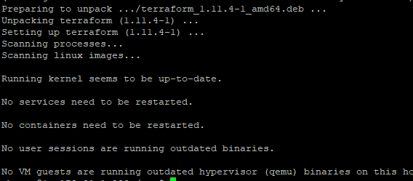

Completed
Terraform version and check installation or not,
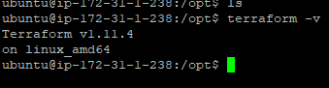

Aws configuration in instance,
Check aws configuration complete or not,
Aws –version
Here not configuration aws in instance so configura that,
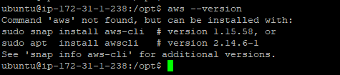

So now we will add aws configuration,
First we need to create user then create access key create,
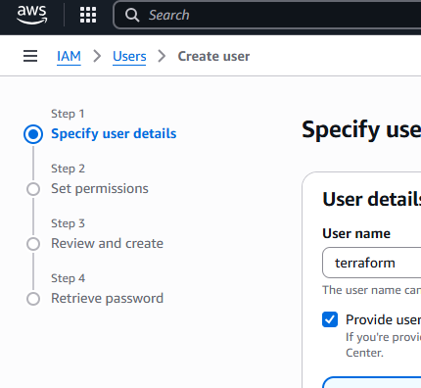

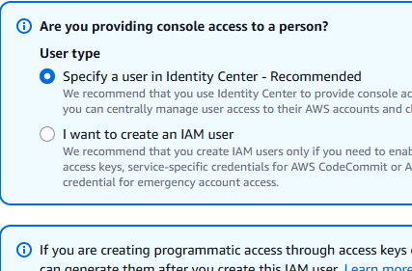

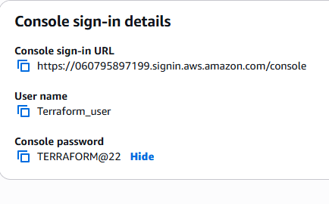
Open user then create access key create,
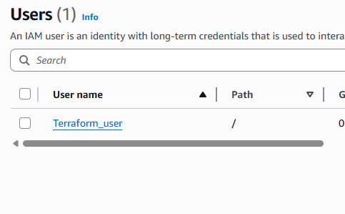

Cleck on create access key,
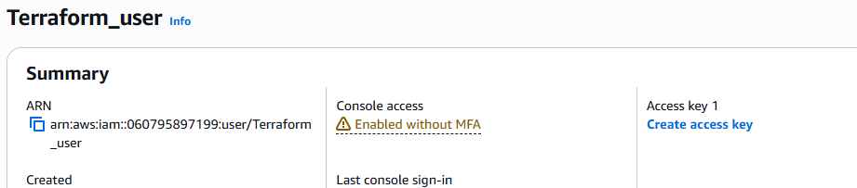

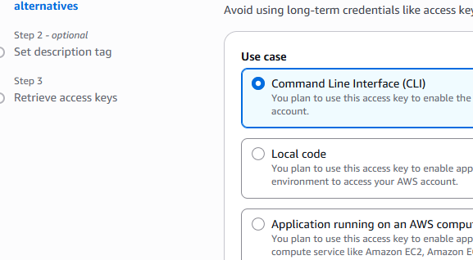

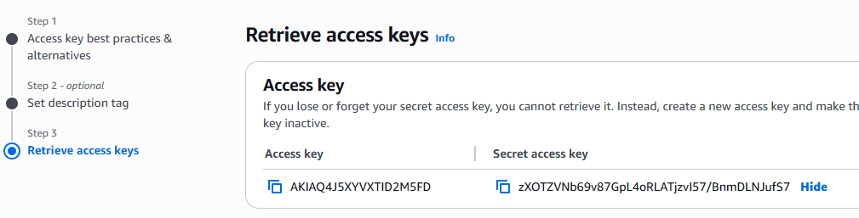

Aws cli installation, we need to installation,
You're almost there! The issue is that:
- The unzip utility is not yet installed, so the AWS CLI ZIP archive hasn't been extracted.
- Because it’s not unzipped, the ./aws/install script doesn't exist yet.
- Therefore, AWS CLI can't be installed or found.

✅ Fix it step by step:

1. Install unzip:
sudo apt install unzip -y

2. Unzip the AWS CLI installer
unzip awscliv2.zip

3. Run the installer
sudo ./aws/install

4. Verify AWS CLI is working
aws --version

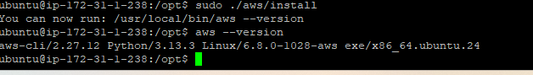
After completed aws-cli then give this details,
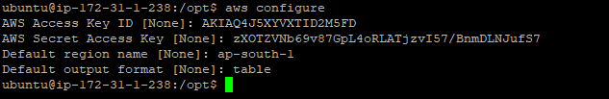

Sudo Terraform init
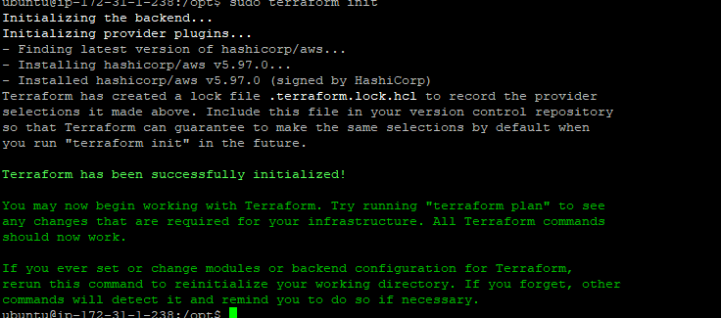

sudo chown -R ubuntu:ubuntu /opt
terraform import aws_instance.myfirst_terraform i-0dece73b3df861649
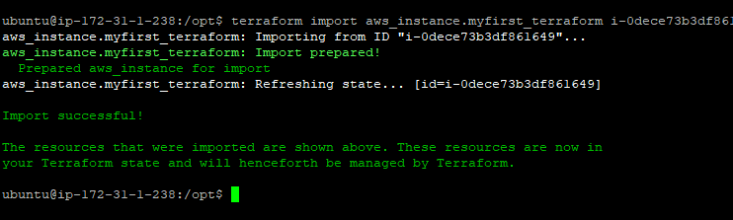

Here give ec2 full access then run this command ------- terraform import aws_instance.myfirst_terraform i-0dece73b3df861649

